# Lab Session 7: Developers Collaboration Using GitHub

## **Example**

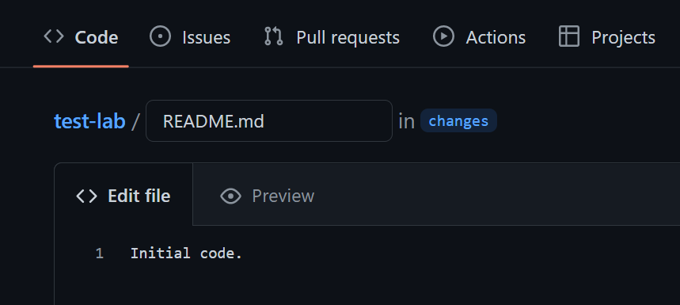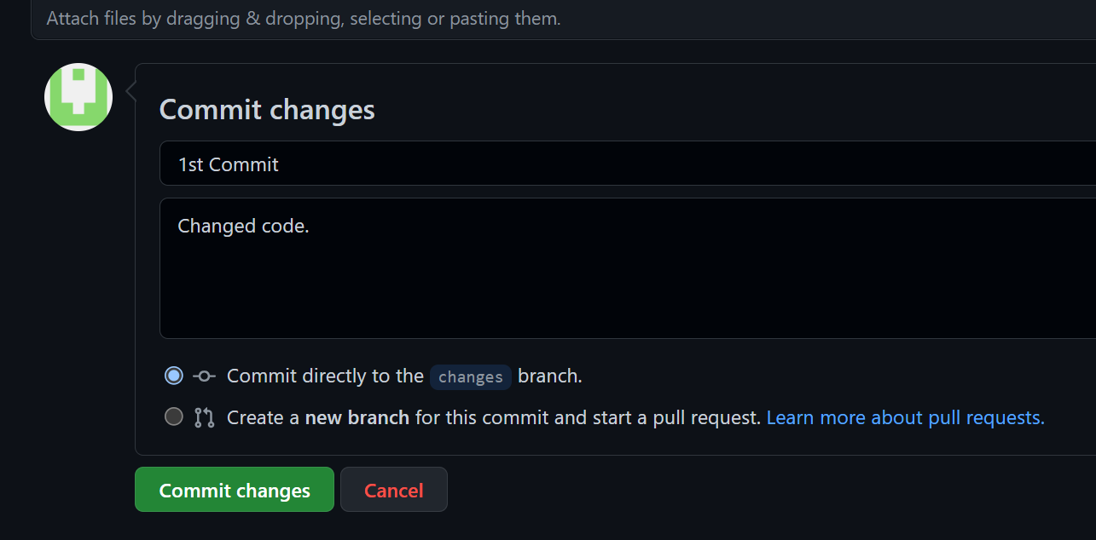

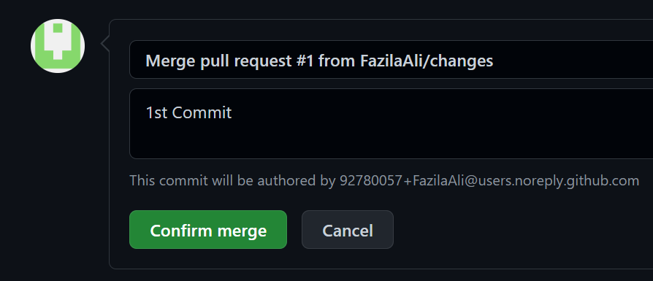

## **Exercise**

1. Log in to your GitHub account at <https://github.com/>.
2. Create a new repository either by clicking the green **New** button or from the dropdown menu on the top right.
3. Name the repository **Exercise1**.
4. Select the checkbox to Add a README file, then click Create repository.
5. Edit the README.md document
6. Add a line with some extra information.
7. Commit the changes.
8. Fork an existing repository (try this: https://github.com/seankross) and try to identify something valuable you could contribute. Make changes or additions to that repository, then open a pull request.

